GOVERNMENT COLLEGE OF NURSING, GSVM MEDICAL COLLEGE KANPUR

“WORKSHOP ON
CERVICAL CANCER SCREENING FOR NURSES N CHO’s”
Government College of Nursing organized ICMR funded Workshop on Cervical Cancer Screening for Nurses and CHO’s in collaboration with Department of Obstetrics and Gynecology, GSVM Medical College Kanpur. Workshop was organized with the aim to train the staff nurses and CHO’s to screen cervical cancer at the earliest using VIA (Visual Inspection with Acetic Acid) and VILI (Visual Inspection with Lugol’s Iodine).
- GENERAL INFORMATION:
- Date: 25th April 2024
- Time: 10:00 am onwards
- Venue: NHM Building, Department of Obstetrics and Gynecological Nursing, Kanpur.

- ORGANIZERS:
- Convener: Lt. Col. Dr. Karesh Prasad,
Professor cum Principal, GCON, Kanpur
- Organizing Secretary: Mrs. Namita Batra
Professor GCON, Kanpur
- Organizing Team:
  - Mrs. Lithiya Jose
Associate Professor, GCON, Kanpur
  - Mrs. Sapna Pal
Tutor, GCON, Kanpur
  - Mrs. Itisha Rose
Tutor, GCON, Kanpur

- RESOURCE PERSON:
- Dr. Neena Gupta
Professor cum HOD, Dept. Obstetrics & Gynecology, GSVM, Kanpur
- Dr. Pavika Lal
Associate Professor Dept. Obstetrics & Gynecology, GSVM, Kanpur

- BENEFICIERIES:
The workshop encompassed 50 participants including staff nurses and CHO’s from different areas of Kanpur city and also faculty from GCON who actively participated in the theory lectures and also in the skill demonstrations.

- EVENTS IN THE WORKSHOP:
Dr. Alok Ranjan, CMO, Kanpur City inaugurated the program with lamp lighting and encouraged the participants to actively screen women at their respective PHC, CHC, hospitals and work together for early detection of cancer and improve the survival chances if detected. Organizing Secretary addressed the audience by her welcome speech and Program Convener also addressed the dignitaries and participants and encouraged to screen and get screened for cervical cancer.
Resource Person Dr. Neena Gupta Dr. Paviak Lal enhanced the learning of the participants by sharing her knowledge and wisdom on the following topics:
S.N | RESOURCE PERSON | TOPIC
1. | Dr. Neena Gupta  Professor & HOD  Dept of Obstetrics & Gynecology | - Cervical Cancer Screening using Visual Inspection by Acetic Acid and Lugol’s Iodine  - Treatment of VIA positive cases using “ Screen-and-treat approach”
2 | Dr. Pavika Lal  Associate Professor  Dept of Obstetrics & Gynecology | - Epidemiology of Cervical Cancer and Disease Burden  - HPV Vaccination

The theory lectures were followed by the skill demonstration of cervical cancer screening on patients in OPD. Entire participants were divided into groups and doctors of obs & Gyne department facilitated them in different OPDs (follow up OPD, Cancer OPD, Colposcopy room, Special OPD).
The program ended with the valedictory session wherein the resource persons were felicitated with the certificates and all the participants were rewarded with the certificates.
The entire workshop was great success and highly knowledge and skill evoking as it enhanced the skills also of staff nurses, CHO and faculties.

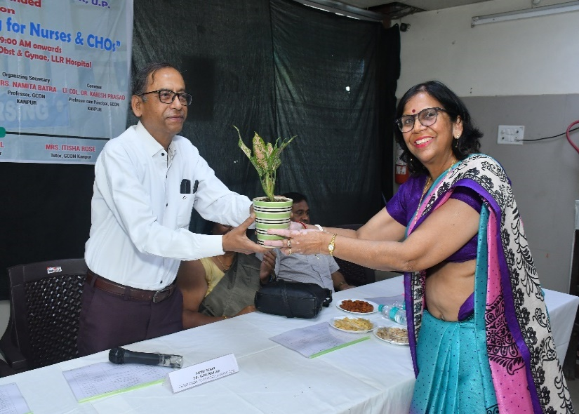
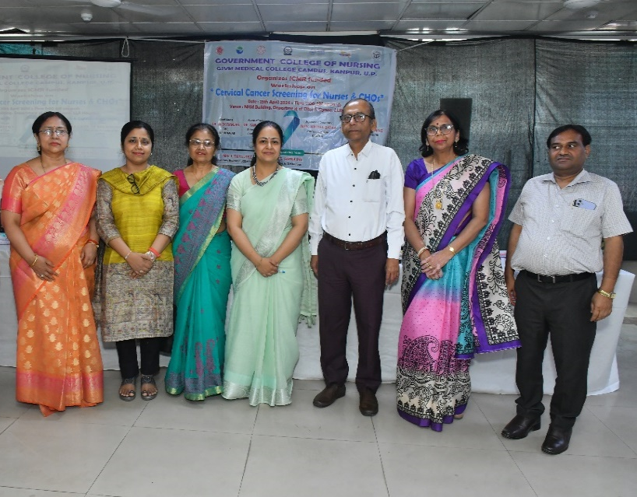
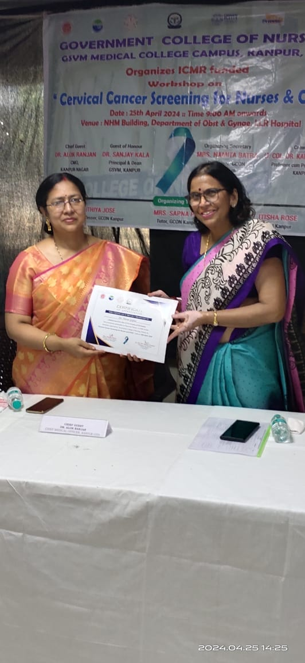
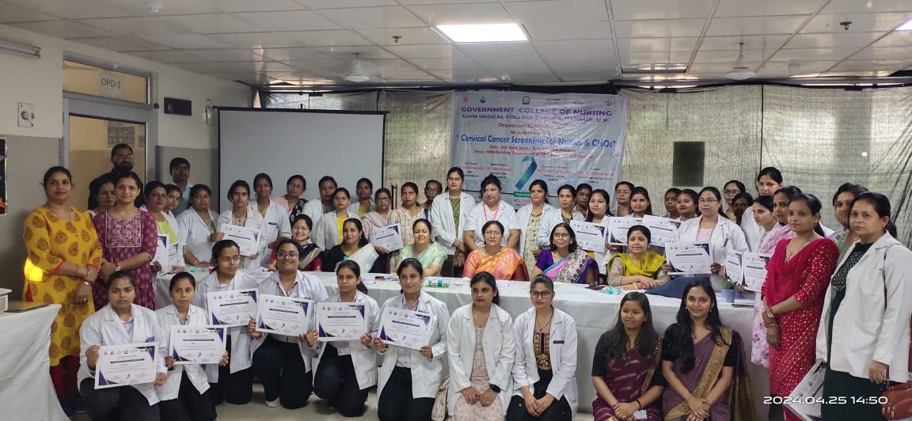
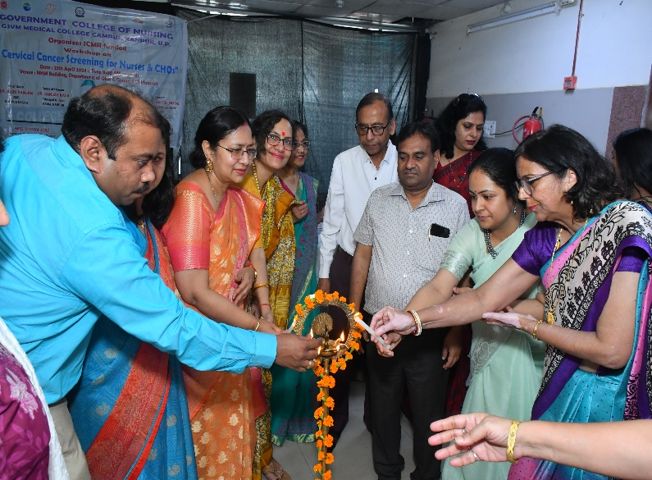
GLIMPSES OF THE WORKSHOP

REPORT
On
ICMR FUNDED WORKSHOP ON
CERVICAL CANCER SCREENING FOR NURSES & CHO’s

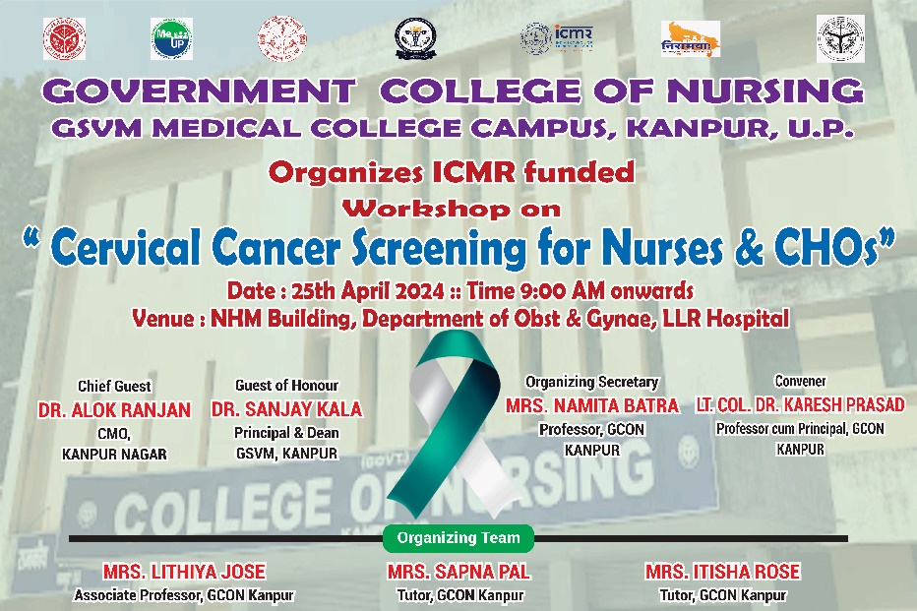

Date : 25.04.2024
Time : 10:00am onwards
Venue: NHM Building, Dept. of Obs & Gyne. LLR Hospital Kanpur

